**Student table task Day-3**

1. **Write a query to display the names of the students those who belongs to 25 years old category.**

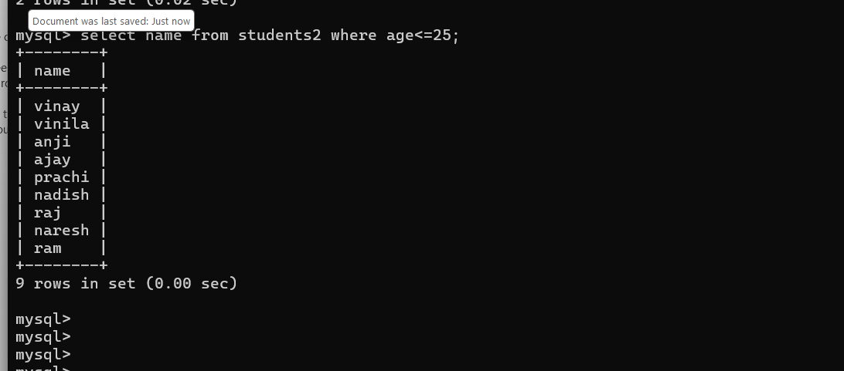

1. **Write a query to display the name of younger student.’**

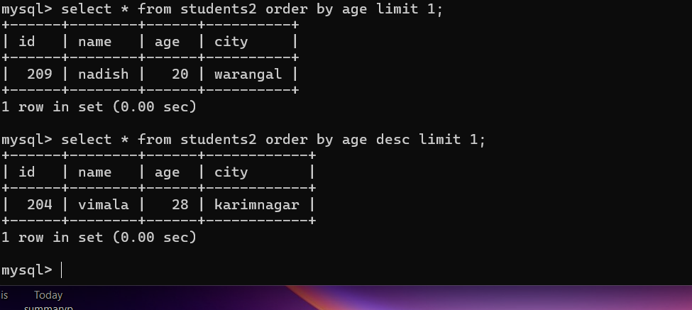

1. **Write a query to display the name of oldest student**



1. **Write a query to display the city name with number of students who belongs to that city in the decreasing order of count.**

